**international communications**

**30-day media report – Research article**

**Original paper:** Influence of agricultural intensification on pollinator pesticide exposure, food acquisition and diversity

**Journal:** Journal of Applied Ecology

**Authors:** Xiaoyu Shi, Changsheng Ma, Joop de Kraker, Shanxing Gong, Jenny A. Hodgson, Shudong Luo, Jozef J. M. van der Steen, Haijun Xiao, Fang Wang, Xiaowei Tie, Zheng Chen, Yi Zou

**Date published:** 3 July 2024

**DOI:**  <https://doi.org/10.1111/1365-2664.14701>

**Title of press release:** To save bees, scientists say focus on habitat first, then pesticides

**Date Published:** 5 July 2024

**URL:** <https://www.xjtlu.edu.cn/en/news/2024/07/to-save-bees-scientists-say-focus-on-habitat-first>

***Note:*** *This press release one of a select number of research articles we have chosen to promote on paid press release distribution services. Therefore, the metrics recording attention and media coverage will be higher than other press releases without paid promotion.*

**Total number of unique readers per month of the media outlets that picked up the article:**

**219,737,244**

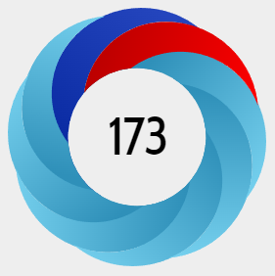**Altmetric score:**

**In the top 1% of all research outputs (approximately 26 million) scored by Altmetric.** [**(For more details…)**](https://www.altmetric.com/details/163882287#score)

The Altmetric Attention Score for a research output provides an indicator of the amount of attention that it has received. The score is derived from an automated algorithm, and represents a weighted count of the amount of attention we've picked up for a research output.

**Number of non-Chinese language media outlets that picked up the media release:**

**155**

**Languages the article has been translated into (not including Chinese):**

**Spanish, Croatian, Italian**

**Number of non-Chinese language media outlets that picked up the media release by country:**

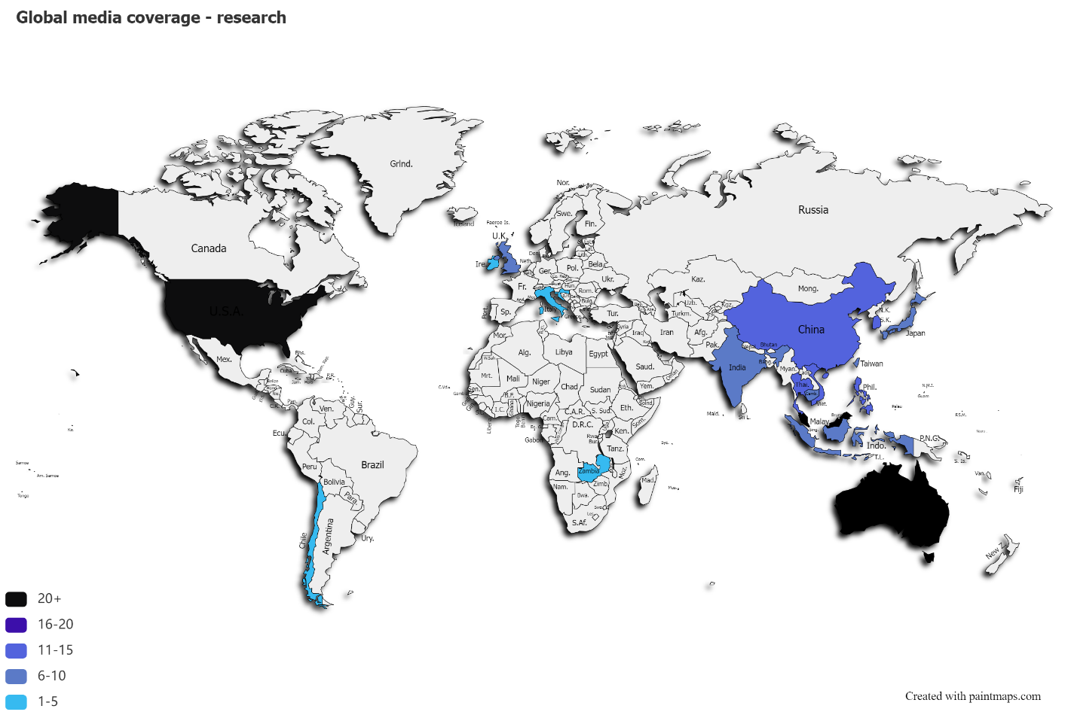

**Advertising value equivalency* (USD):**

**$413,010.03**

*Advertising value equivalency (AVE) is used to measure the dollar value of media coverage. AVE measures the size of the media coverage, the space it was put, and calculates the advertising rate for a similar ad.

**Thanks for your support and we look forward to working with you again!**

**The International Communications Team**